Chapter 2

**Software Requirement Specifications**

**Chapter 2:** Software Requirement Specifications

1. 1. **Introduction**
      1. **Purpose**

In this chapter, the architecture of the whole project is analyzed. System analysis is the process of defining the architecture, components, and data of a system to satisfy specified requirements. Design is a method of studying a system by examining its component parts and their interactions. Before implementation began the system was analyzed and designed. In this section, use cases.

* + 1. **Document Conventions**

Describe any standards or typographical conventions that were followed when writing this SRS, such as fonts or highlighting that have special significance. For example, state whether priorities for higher-level requirements are assumed to be inherited by detailed requirements, or whether every requirement statement is to have its own priority.>

* + 1. **Intended Audience and Reading Suggestions**

<Describe the different types of reader that the document is intended for, such as developers, project managers, marketing staff, users, testers, and documentation writers. Describe what the rest of this SRS contains and how it is organized. Suggest a sequence for reading the document, beginning with the overview sections and proceeding through the sections that are most pertinent to each reader type.>

* + 1. **Product Scope**

This application focused on the enhancement of buying home appliances and other electronics while comparing their specifications and prices from showrooms/stores nearby the users by using Smartphones. More specifically, this application involves the conceptualization, design, development, evaluation and application of innovative ways to use information and communication technologies (IT) in this domain. The concept of this application is relatively new and we fully expect its scope to change and evolve as our understanding of the area grows.

But there are some advantages and drawback which reside in every technology.

* + 1. **References**

List any other documents or Web addresses to which this SRS refers. These may include user interface style guides, contracts, standards, system requirements specifications, use case documents, or a vision and scope document. Provide enough information so that the reader could access a copy of each reference, including title, author, version number, date, and source or location.>

* 1. **Overall Description**
     1. **Product Perspective**

There is not a single mobile application available right now for people living in major cities which provides the facilities like buying home appliances and other electronics while comparing their specifications and prices from the showrooms or outlets of different companies nearby the user with the facility of home delivery.

Currently, most people go to one or two outlets and buy what the want without knowing that the same product is available in low price or with discount from the next outlet and they spend their hours in searching of showrooms/outlets and discounts. Mostly people don’t want to visit more than 3 outlets of different companies or don’t want to roam around the city.this application will help people to buy their favorite appliances in low prices and there will be no worry to hire a pickup or truck to make it to home.

On the other hand the outlets will be able to sell their products on this application and they also don’t have to do anything regarding the delivery to the customer and this will boost their selling.

* + 1. **Product Functions**

There are four main functionalities of our application.

1. Providing facility for user to compare different outlets prices for same product and purchasing of that product while at home doing other stuff.

2. Home delivery of products.

3. Repairing and maintenance Services

4. Providing a platform for sellers to sell their products online.

* + 1. **User Classes and Characteristics**

On this platform we will provide the following features.

Purchasing:

1. Purchase home appliances
2. Compare same or different products
3. Compare prices same product available at different outlets

Selling (Only for outlets or companies of home appliances):

1. Selling products online
2. Manage selling and profits online

Home Delivery and Services:

1. Home delivery for customers
2. Repairing and maintenance services at door step
   * 1. **Operating Environment**

The application will run on android mobile with enable internet services. The specific requirements are given below:

Android mobile/tablet

1GB RAM

Android

* + 1. **Design and Implementation Constraints**
       1. **Internet Availability**

To use this application, the internet is very important. Without internet this application will never work.

* + - 1. **Account Registration**

To use this application, the user must have an account to login and perform the task that is required of that user

* + - 1. **Better Communication**

Meet now must provide the facility of better communication using high speed internet connection.

* + 1. **User Documentation**

Our Application will be online if any reader requires any help understanding the document they can obtain from there our emergency help line numbers are also provided on our application so they can contact with us in case of any emergency regarding our application. In short any help required will be available on our application.

* + 1. **Assumptions and Dependencies**

**Stream Confidentiality**

Steam Confidentiality must be maintained ISU (independent stream unit). By this user have full control over streams.

**Accurate Records**

ISU must shows accurate records.

* 1. **External Interface Requirements**

* + 1. **User Interfaces**

The user interface for the application shall be compatible to any android device for 5.1 to android 10. . The tools and technique which is use for this development are

* Android studio
* java
* Sqlite
* Firebase
  + 1. **Hardware Interfaces**

Since the application must run over the internet, all the hardware shall require to connect internet will be hardware interface for the system.

* + 1. **Software Interfaces**

1. The application shall communicate with the Configuration to identify all the available components to configure the product.

2. The application shall communicate with the content manager to get the product specifications, offerings and promotions.

3. The application shall communicate to credit management system for handling financing options.

4. The application shall communicate with CRM system to provide support.

5. The application shall communicate with Sales system for order management.

6. The application shall communicate with shipping system for tracking orders and updating of shipping methods.

7. The application shall communicate with external Tax system to calculate tax.

8. The application shall communicate with export regulation system to validate export regulations.

10. The system shall be VeriSign like software which shall allow the users to complete secured transaction. This usually shall be the third party software system which is widely used for internet transaction.

* + 1. **Communications Interfaces**

The e-store system shall use the HTTP protocol for communication over the internet and for the intranet communication will be through TCP/IP protocol suite.

* 1. **System Features**

This subsection contains the requirements for the e-store. These requirements are organized by the features discussed in the vision document. Features from vision documents are then refined into use case diagrams and to sequence diagram to best capture the functional requirements of the system. All these functional requirements can be traced using tractability matrix.

* + 1. **Sell Configured to Ordered Products.**
* The system shall display all the products that can be configured.
* The system shall allow user to select the product to configure.
* The system shall display all the available components of the product to configure
* The system shall enable user to add one or more component to the configuration.
* The system shall notify the user about any conflict in the current configuration.
* The system shall allow user to update the configuration to resolve conflict in the current configuration.
* The system shall allow user to confirm the completion of current configuration
  + 1. **Provide comprehensive product details.**
* The system shall display detailed information of the selected products.
* The system shall provide browsing options to see product details.
  + 1. **Detailed product Categorizations**
* The system shall display detailed product categorization to the user.
  + 1. **Provide Search facility.**
* The system shall enable user to enter the search text on the screen.
* The system shall enable user to select multiple options on the screen to search.
* The system shall display all the matching products based on the search
* The system shall display only 10 matching result on the current screen.
* The system shall enable user to navigate between the search results.
* The system shall notify the user when no matching product is found on the search.
  + 1. **Maintain customer profile.**
* The system shall allow user to create profile and set his credential.
* The system shall authenticate user credentials to view the profile.
* The system shall allow user to update the profile information.
  + 1. **Provide personalized profile**
* The system shall display both the active and completed order history in the customer profile.
* The system shall allow user to select the order from the order history.
* The system shall display the detailed information about the selected order.
* The system shall display the most frequently searched items by the user in the profile.
* The system shall allow user to register for newsletters and surveys in the profile.
  + 1. **Provide Customer Support.**
* The system shall provide online help, FAQ’s customer support, and options for customer support.
* The system shall allow user to select the support type he wants.
* The system shall allow user to enter the customer and product information for the support.
* The system shall display the customer support contact numbers on the screen.
* The system shall allow user to enter the contact number for support personnel to call.
* The system shall display the online help upon request.
* The system shall display the FAQ’s upon request.
  + 1. **Detailed invoice for customer**
* The system shall display detailed invoice for current order once it is confirmed.

The system shall optionally allow user to print the invoice.

* 1. **Other Nonfunctional Requirements**

Functional requirements define the needs in terms of performance, logical database requirements, design constraints, standards compliance, reliability, availability, security, maintainability, and portability.

* + 1. **Availability:**
* Application must be responsive and available at every time.
* Availability of high speed internet connection is the major requirement of the application.
* Application must be work on time efficiently.
* Application connectivity time must be good.
  + 1. **Maintainability:**
* Making changes or upgradeability in the site will not be that much difficult. By having some knowledge of programming, some features of the application might be converted to a new version.
* It can be easily upgraded and admin should maintain their performance efficiently.
  + 1. **Performance:**
* This application must perform the action on time without any long delay.
* Over Application through an output in time.
* This Application performs efficiently.
  + 1. **Security:**
* This Application prevent from unauthorized modification of information.
* Security factors are very important in over Application.
  + 1. **Usability:**
* This application fulfills the requirement of global User and Admin.
* All type of people must access of this application.
  + 1. **Portability:**
* This is android server based application that is why there is no problem in portability process.
  + 1. **Supportability:**
* This Application support and provide Information helpful for identifying and resolving issues when it fails to work correctly.
  1. **Other Requirements**

There are no other requirements or specific thing needed to run the application or to run it in development phase all of the information is written above for better understanding.

Chapter 3

**Use Case Analysis**

1. **System Analysis**

An important part of the analysis phase is to drawing the diagrams of Use cases. They are used through the phase of analysis of a project to find and divide functionality of the application. Application is separated into actors and use cases. Actors play the role that are played by the application users.

* 1. **Use Case Model**

Use cases define the application behavior when one of the actors sends any particular motivation. This type of behavior can be described by text. It describes the motivation nature that activates use case, the inputs and outputs to some other actors and the behavior of conversion of inputs to the outputs. Usually the use case describes everything that can go wrong during the detailed behavior and what will be helpful action taken by the application.

Some of the use cases are as follows:

### Use Case

**Use case Diagram of Customer**

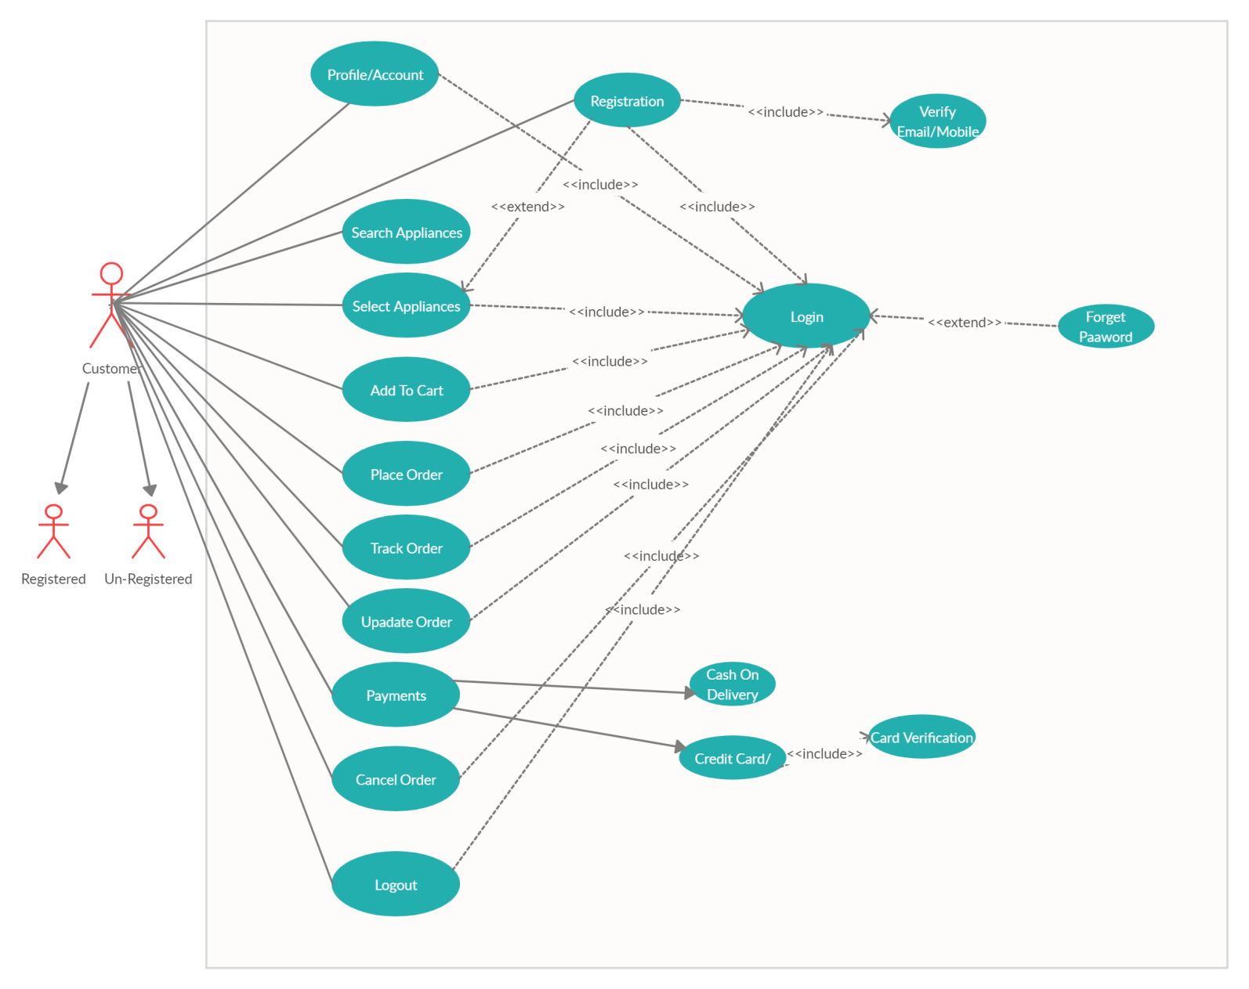**Figure 3.1 Use Case 1**

### Use Case

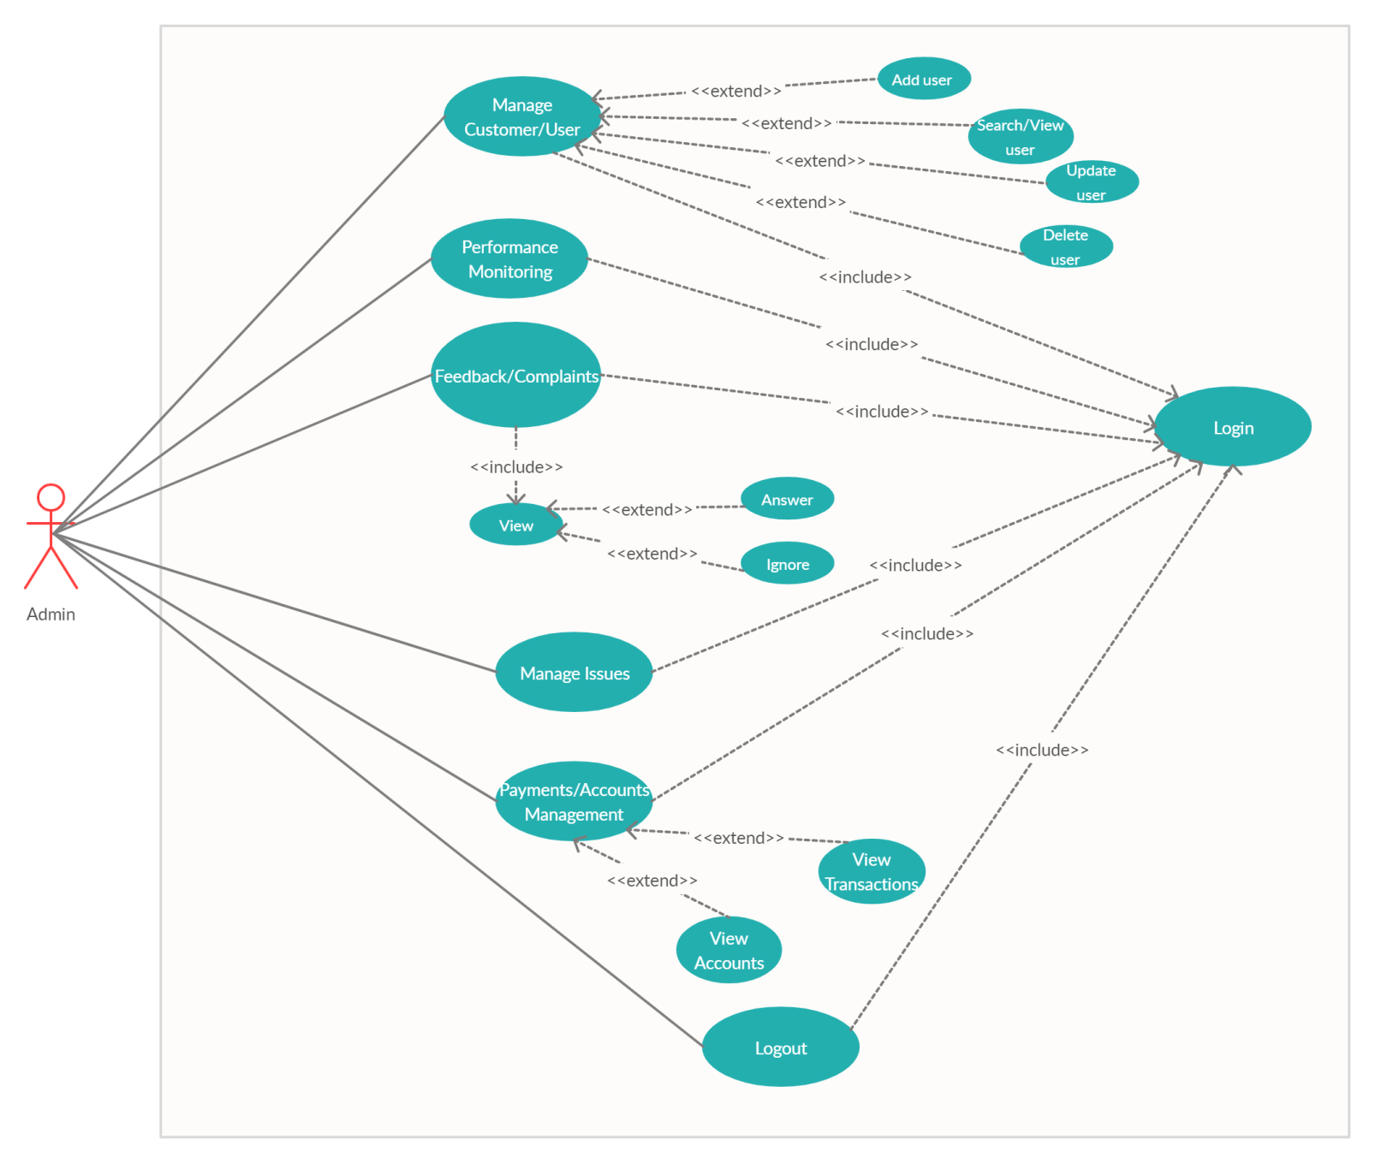**Use case Diagram of Administrator**

#### Figure 3.2 Use Case 2

### Use Case

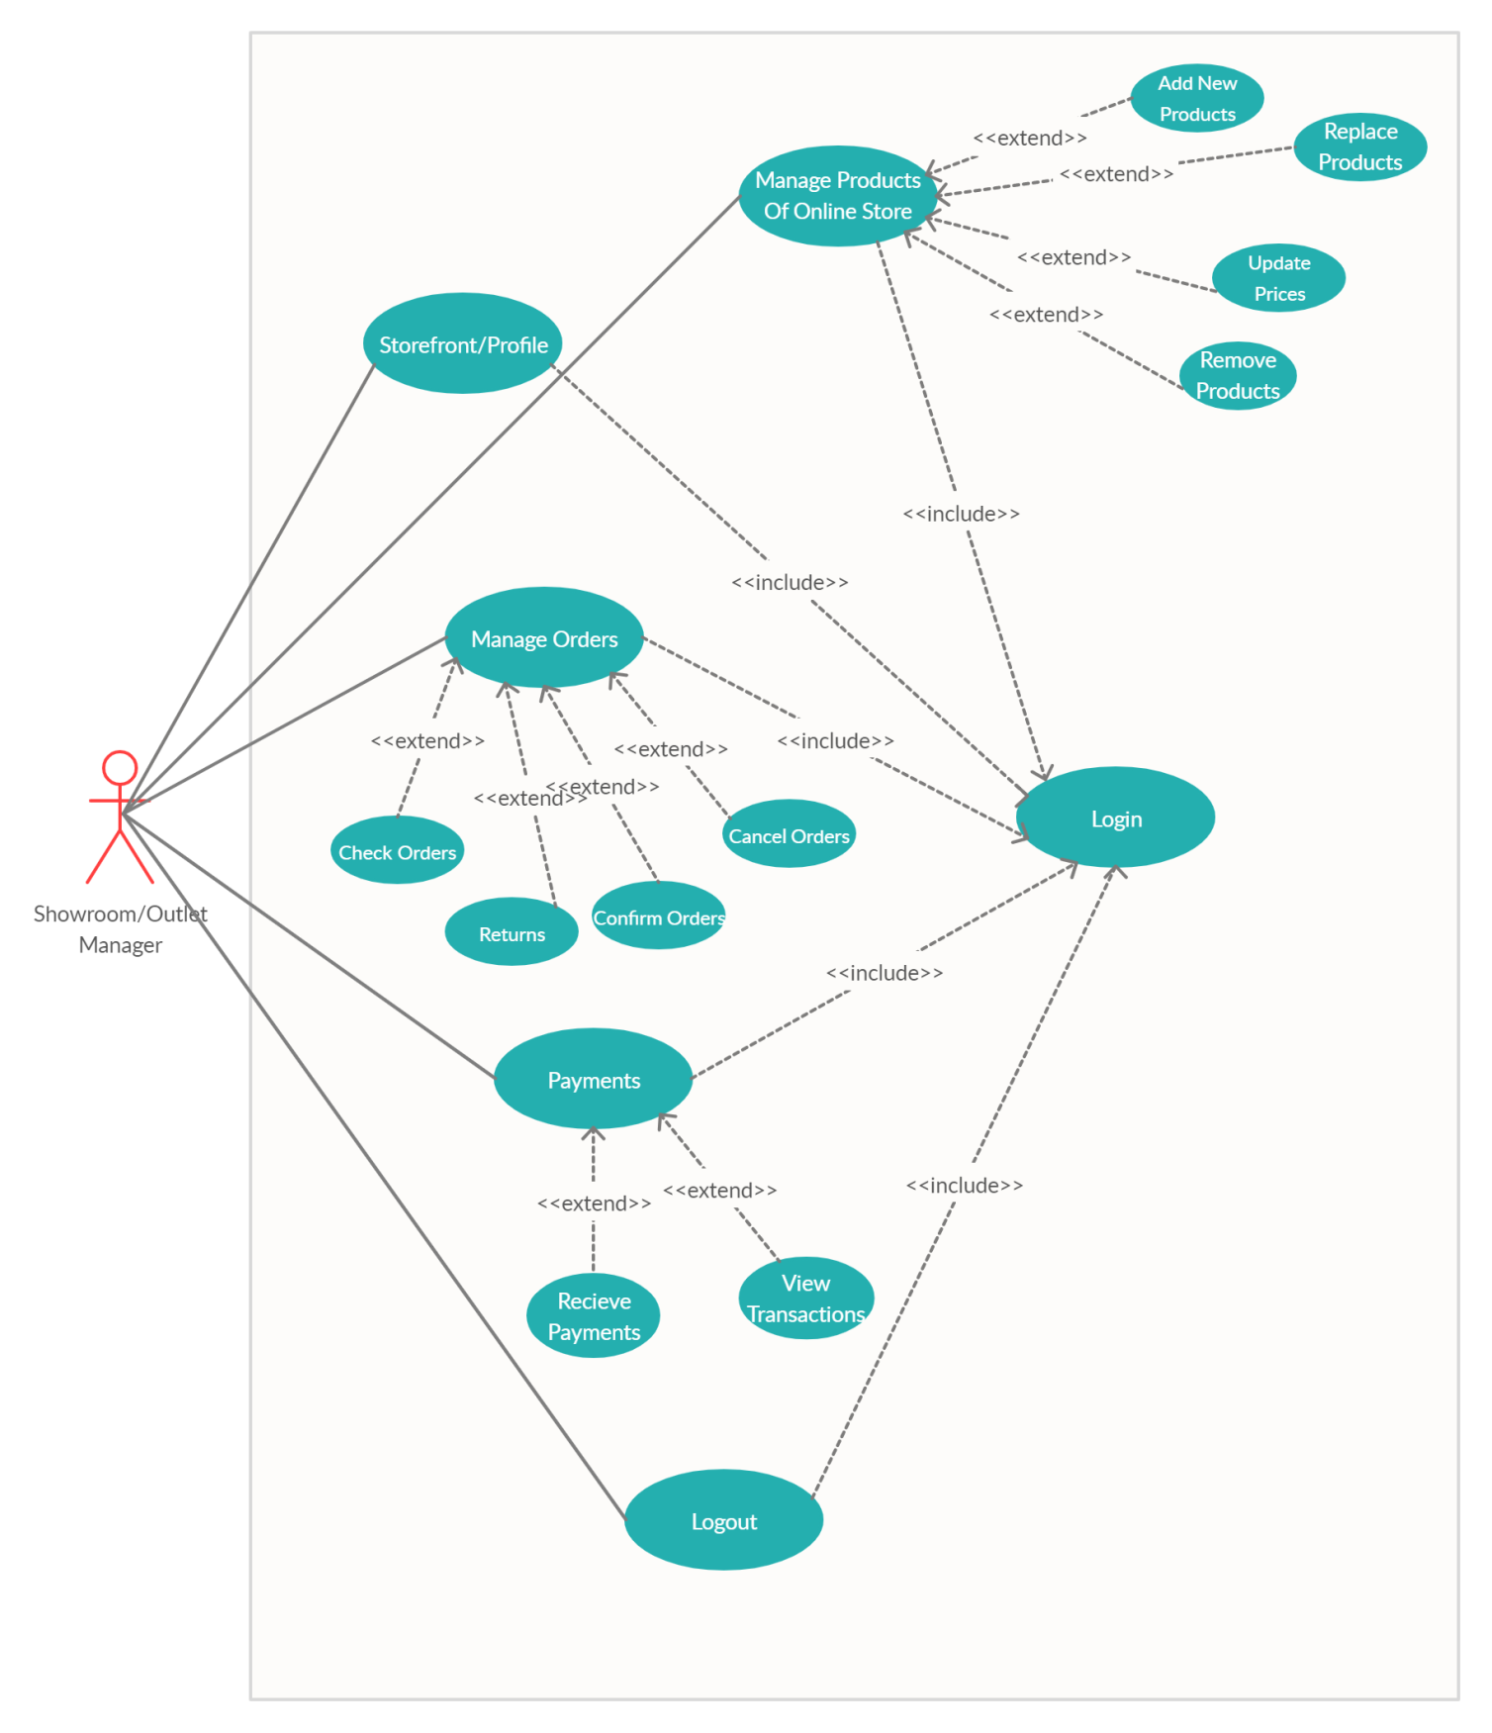**Use case Diagram of outlet/showroom Manager**

**Figure 3.3 Use case 3**

### Use Case

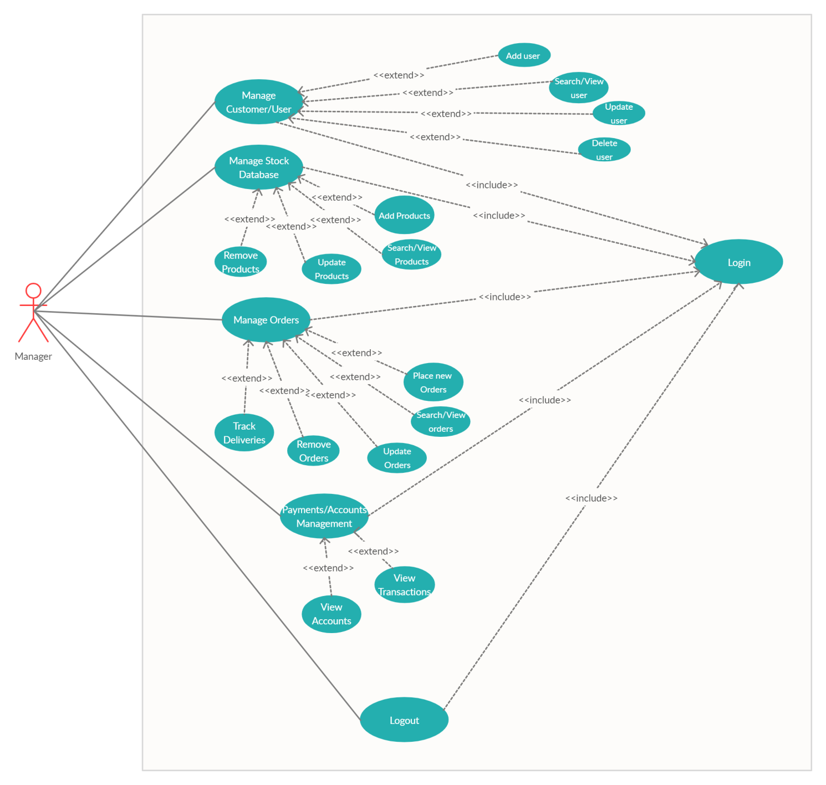**Use case Diagram of Manager**

**Figure 3.4 use case 4**

* 1. **Use Case Specification**

**Customer**

|  |  |
| --- | --- |
|  |  |
|  | **Customer** |
| **ID:** | **1.1.1** |
| **Brief Description:** | **All functions of customer** |
| **Actors:** | **customer** |
| **Preconditions:** | **Customer must be login or sign up first** |
| **Main Flow:** | **Search, view, select and order products** |
| **Post Condition:** | **Able to search and order products** |
| **Alternative flows:** | **Login or sign up fail and forget password** |

**Admin**

|  |  |
| --- | --- |
|  |  |
|  | **Admin** | |
| **ID:** | **1.1.2** | |
| **Brief Description:** | **All functions of Administrator** | |
| **Actors:** | **Admin** | |
| **Preconditions:** | **Admin must be login or sign up first** | |
| **Main Flow:** | **Manage users, accounts/payments and complaints/feedbacks** | |
| **Post Condition:** | **Able to add or view user, payments and system monitoring** | |
| **Alternative flows:** | **Login or sign up fail and forget password** | |

**Outlet/showroom Manager**

|  |  |
| --- | --- |
|  |  |
|  | **Outlet/showroom Manager** | |
| **ID:** | **1.1.3** | |
| **Brief Description:** | **All functions of online store/shop manager** | |
| **Actors:** | **Outlet/showroom manager** | |
| **Preconditions:** | **must be login or sign up first** | |
| **Main Flow:** | **Manage products, payments and orders** | |
| **Post Condition:** | **Able to view orders, payments and products** | |
| **Alternative flows:** | **Login or sign up fail and forget password** | |

**Manager**

|  |  |
| --- | --- |
|  |  |
|  | **Manager** | |
| **ID:** | **1.1.3** | |
| **Brief Description:** | **All functions of manager** | |
| **Actors:** | **Manager** | |
| **Preconditions:** | **must be login first** | |
| **Main Flow:** | **Manage users, stock, orders and payments** | |
| **Post Condition:** | **Able to add and view users, orders, payments and products** | |
| **Alternative flows:** | **Login or sign up fail and forget password** | |